**Online Book Store System**

**Problem Statement:**

People find it difficult to visit a bookstore in-person whenever they require any book. This causes a necessity to design a system that gives an alternative mode of buying the required books from wherever they are.

**Project Justification:**

A system to purchase books online and to store the inventory data securely can be built using MySQL inside the GCP environment. This system gives people an alternative mode of buying required books online on a first come first serve basis, rather than visiting the store.

**Project Characteristics and Requirements:**

* Secured database
* Cloud hosted service
* Easy navigation
* Integrated payment systems
* User history tracked

**Project Success Criteria:**

Our main goal is to develop a light software that can serve as a tool for purchasing required books at the ease of the buyer, irrespective of where they are.

**Scope of Work:**

The online book store system can be used by people across the world, to purchase the required books. Users who are 12+ years old can handle the software without much difficulty in processing their purchase. The software can be designed in a way to easily adapt updates and additions to its features, thus making it useful in the long term. Since books are purchased online, the cost associated with displaying the books in shops as well as maintenance costs can be cut down.

**Features:**

* Selection of books is done using the system through a simple registration process, wherein a form can be filled by the user provided by the website. These form responses can be stored using MySQL in the Google Cloud Platform.
* User login is authenticated.
* Add to cart option for books selected.
* Easy to use

**Implementation:**

**Application Frontend:**

A full stack web application is created using HTML, CSS, JavaScript, Node.js, Express.js. The frontend is connected to a MySQL database to maintain the inventory of books.

The GUI of the application is as follows:

1. Log in/sign up page



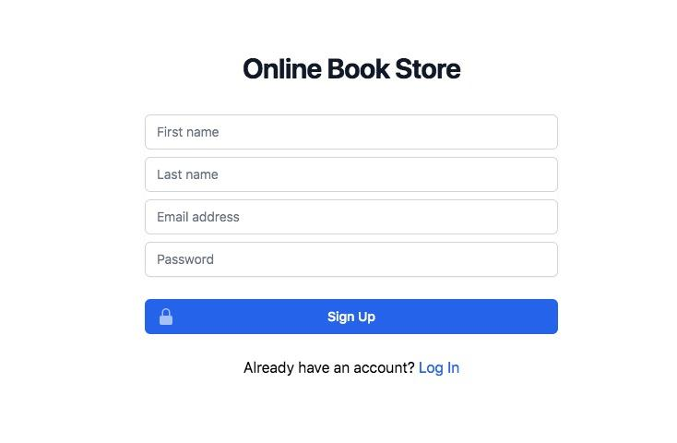

1. The Dashboard containing books and their details

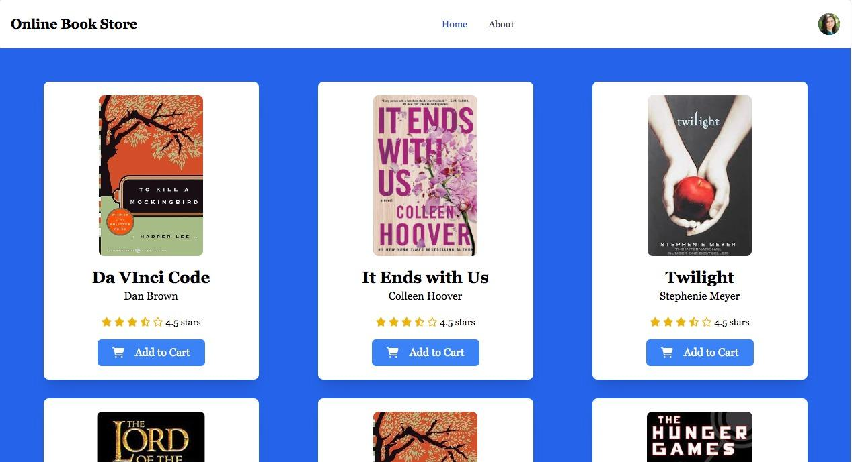

1. Book recommendations with provision to add to cart



**MySQL Database:**

MySQL is one of the easy to understand and proficient languages available today, and its features can be utilised efficiently to build an online system for storing data related to the books.

Database - online_book_store

Tables - inventory, users

**Inventory**

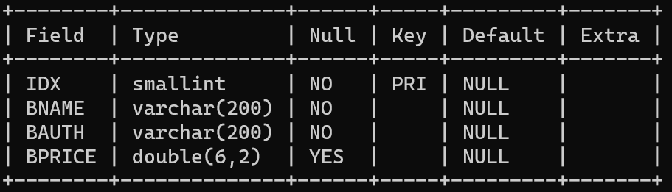

**Book inventory with details**

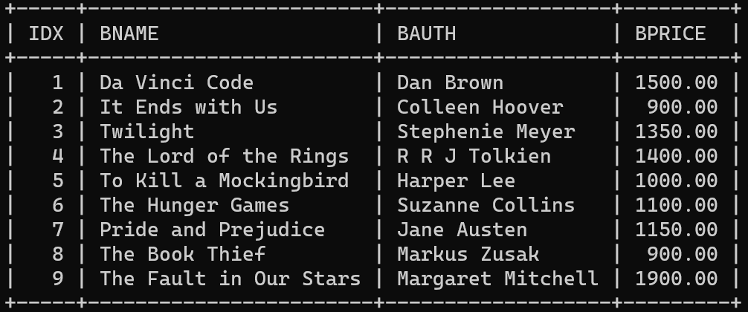

**Users**

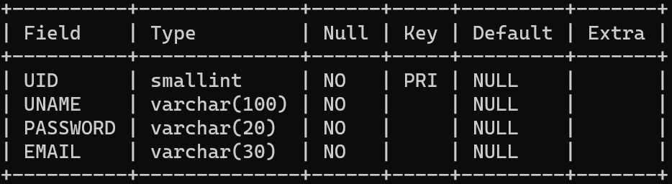

**Successful creation of user**

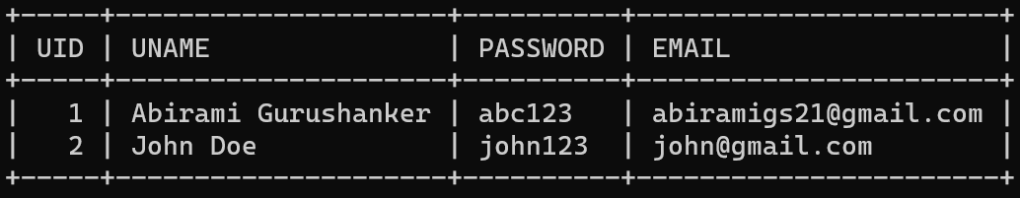

**Google Cloud Resources required:**

* Compute engine - Virtual machine to host web application
* Cloud SQL - Backend MySQL database to store book details
* Cloud Storage - Storing book cover thumbnails and users’ profile picture

**Suggestive Additions to the Project:**

The following features can be added to the project with subsequent updates:

* Provision for returning books
* Request for books not in list/out of stock
* Option to review books
* Subscription to auto-deliver newsletters/magazines for every edition.
* Donate money/new books/used books to help educate underprivileged children
* Provide an online sample of a few pages per book, to encourage users to purchase the product.